Chess Visualisation

Specification Version: 1.1 (Released 7th August, 2025, updated 15th August 2025)
Changelog:
- 1.1 - bumped deadline to avoid confusion about timing between Ed and the spec.
- 1.1 - added links to our course style guide.
The deadline for Assignment 1 is 8th September, 2025 10:55pm (Canberra time, sharp).
However, the first parts of this assignment can be completed earlier! Start early and avoid crunch-time stress!
Note: Late submissions will not be marked unless you have an approved extension. Extensions can only be applied for through the Extension App. Students with Education Access Plans still need to use this App.
Use the "Submit" button on the top-right corner to submit your code to our server. You must submit at least once before the deadline. You can submit as many times as your want before the deadline; only your latest submission counts.

The ChessGraphics Library
This assignment makes use of a library, a pre-written module containing types and functions that you should use to implement your solution. The ChessGraphics library includes a variety of built-in functions to manipulate Pictures, which you will use to visualise chess boards. The source code to the library has been included in your Ed Lessons scaffold, but you should not have to read the source code to understand how to use the library. Instead, we recommend you consult the automatically-generated documentation for the library. This documentation lists all the functions and types that this library makes available to you, including a brief explanation of each function.
Most importantly, this library defines a command render that, given a Picture as input, saves an image (in vector format) into a file called svgOut.svg. To try this out, first load the assignment in ghci from the Terminal:
ghci -Wall Chess.hs
Then, we'll render a small example Picture:
ghci> render (above queen (beside knight king))
To view this image, it's easiest to use the provided showPic.html file. To do this in Ed Lessons, right click the file showPic.html and click "Open in Web Preview". This will display your image in a basic web page from within Ed.
The "Console" that shows in the web preview can be closed. It is not used for this assignment.
The provided example picture above should look like this:
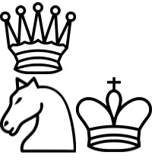
If you subsequently render a different Picture, you will need to reload the preview page to see the updated image. In Ed Lessons, this is achieved by pressing the reload button in the top-right of the Web Preview tab.

Part 0 (2 marks)
This part (and only this part) of the assignment may be freely discussed with your peers and with your tutor.
No anti-plagiarism restrictions apply to Part 0.
Required Knowledge: Weeks 1-2 lecture content.
Marking: 1 mark for blackSquare, 1 mark for backRankPieces
The ChessGraphics library defines a Picture for a "white" square of a chess board, called whiteSquare , but it doesn't include a Picture for the "black" squares. I use "quotes" here because while these squares are called "white" and "black", typical chess boards use different colours — it suffices that one colour is the inverse of the other. Using the functions available to you from ChessGraphics , define blackSquare in the file Chess.hs. If you implement it correctly, then render (beside blackSquare (beside whiteSquare blackSquare)) should produce:

Next, define backRankPieces, which is a picture consisting of all the pieces that start in the "back rank" of a Chess board, in order. When rendered, it should look like this:
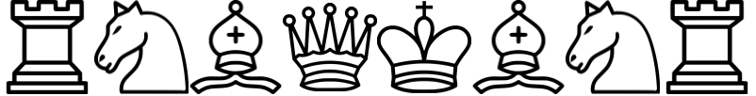
The Test button in the lower-right corner can be used to conveniently test all your code against all of the examples presented in this specification. However, these examples are not sufficient to ensure your solutions to all of the problems are correct.

Part 1 (13 marks)
Required Knowledge: Weeks 1-2 lecture content.
Marking: 10 marks for correct implementation of piecePicture. 3 marks for style.
Note that all parts (except for part 0) of this assignment reserve some marks for style. We have a style guide which gives precise instructions. In general, please consider the following style guidelines:
- Avoid repetition (while maintaining clarity).
- Choose reasonable names for variables and functions.
- Use ghci with -Wall and fix all warnings.
- Any unclear part of the program should be explained with a comment.
In Chess.hs we defined for you a data type called Piece, a product of Colour and PieceType:
1
2
3
4
5
6
Your next task is to define the function piecePicture:
piecePicture :: Piece -> Picture

which, given a Piece, produces the appropriate Picture for the given PieceType. If the Colour of the Piece is Black, then the Picture should be inverted.
If you implement it correctly, render (beside (piecePicture (Piece White Knight)) (flipV (piecePicture (Piece Black Knight)))) should produce:


Part 2 (40 marks)
Required Knowledge: Weeks 1-3 lecture content.
Marking: For each of repeatH, repeatV: 10 marks for correct implementation, 3 marks for style. For board, 10 marks for correct implementation, 4 marks for style.
Implement the two functions repeatH and repeatV. These functions
repeatH :: Picture -> Int -> Picture
repeatV :: Picture -> Int -> Picture

These two functions both take a Picture p and an Int n, and produce a Picture that consists of n copies of p, either stacked above each other (for repeatV ) or beside each other (for repeatH). If n <= 0, the Picture produced should just be empty.
If implemented correctly, render (beside (repeatV queen 3) (repeatH king 3)) should produce the following:
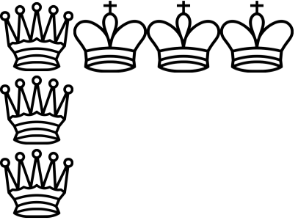
Next, define board, which is a Picture representing the Chess board in its initial configuration at the start of play. When correctly implemented, render board should produce:
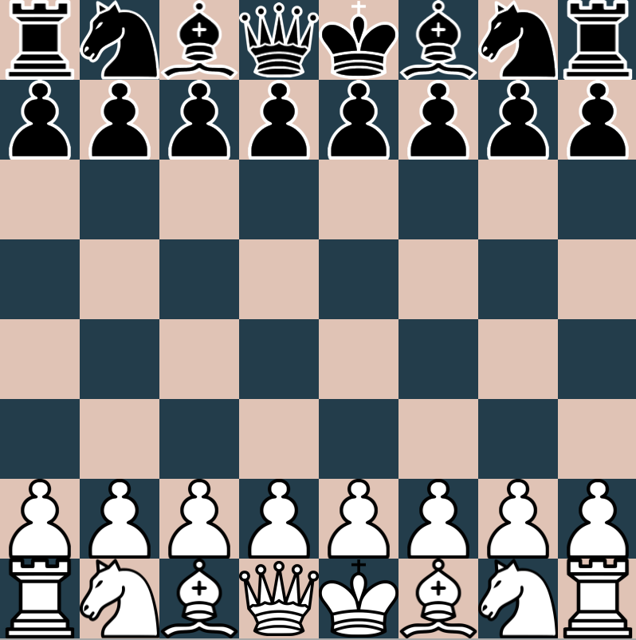
Hint: It is often helpful to break down problems like this into subproblems. Consider dividing the board up into three parts — the top two ranks, the empty middle part of the board, and the bottom two ranks — and drawing each of these separately. These problems can be further subdivided: The top two ranks consists of the backRankPieces and a row of pawns, placed over the checkerboard background, for example.

Part 3 (45 Marks)
Required Knowledge: Weeks 1-4 lecture content.
Marking: For each of combineH, combineV: 10 marks for correct implementation, 3 marks for style. For boardFor, 15 marks for correct implementation, 4 marks for style.
Implement the two functions combineH and combineV. These functions
combineH :: [Picture] -> Picture
combineV :: [Picture] -> Picture

These two functions both take a list of Pictures ps, and produce a Picture that consists of each element of ps in order,, either stacked above each other (for combineV ) or beside each other (for combineH). If ps is the empty list [], the Picture produced should just be empty.
If implemented correctly, render (beside (combineH [king,queen,knight]) (combineV [rook,pawn,bishop])) should produce the following:
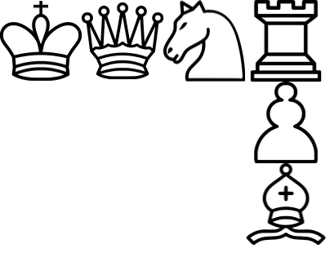
Lastly, the file Chess.hs defines two type synonyms:
1
2
The type Position therefore refers to a pair of two Ints, row and column respectively, referring to a position on the chess board. The state of a Chess game (GameState) is described by a list of every Piece in play, along with its Position on the board.
In some chess notations, row 1 refers to the bottom of the board, while row 8 refers to the top. This is not the case for our Position type. In our type, row 0 refers to the top of the board and row 7 refers to the bottom.
Implement the function boardFor, which, given a GameState as described above, produces the Picture visualising that state of the chess board. You may implement this function in any way you see fit, however we offer this suggested strategy:
- Implement a function backdropFor :: Position -> Picture that returns either whiteSquare or blackSquare depending on the colour of the input Position on the chess board.
- Implement a function piecePictureFor :: GameState -> Position -> Maybe Picture that searches through the provided list (GameState) for a Piece at the provided Position, returning Just its corresponding Picture (using your previously-implemented piecePicture) if it exists. The lookup function from the Prelude is helpful here.
- The implementation of boardFor should use combineV to merge a list of all the rows of the board.
- Each row of the board should be defined with combineH to merge a list of all the cells in the row.
- Each cell should be defined as the piecePictureFor that position (if there is a piece there), over the backdropFor that position.
Dealing with invalid inputs
You may assume that all Position values only contain coordinates between 0 and 7 inclusive, and that two Pieces never occupy the same Position. Nonetheless, we encourage you to handle invalid inputs gracefully. Pieces placed at positions outside the board or which are already occupied can, in this case, be safely ignored and not displayed anywhere.
You may not assume any other Chess rules (e.g. that there are exactly two kings).
The file Examples.hs contains a few examples of GameState definitions you can use for your testing. Load the file by typing in the terminal ghci -Wall Examples.hs.
- render (boardFor emptyBoard) will produce an empty board as follows:
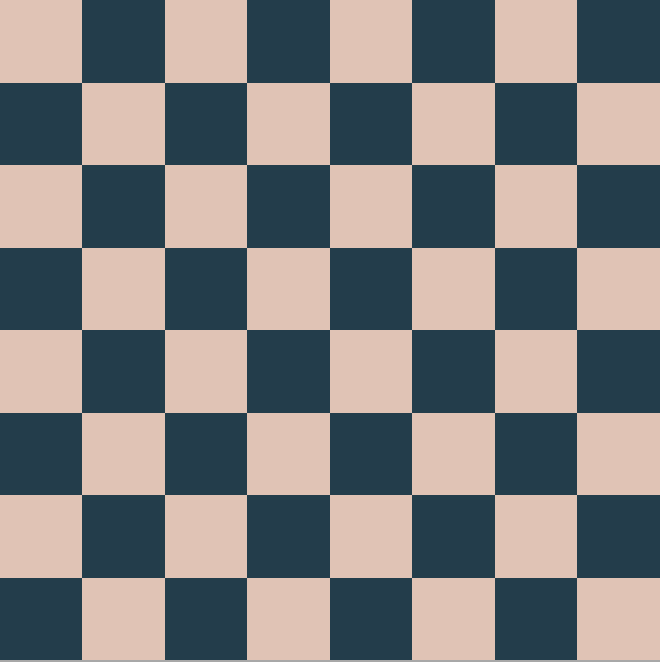
- render (boardFor starting) will produce the starting configuration of a game of chess, as seen above when you implemented board.
- render (boardFor scholarsMate) will produce a visualisation of the popular Scholar's Mate, an opening that can checkmate in 4 moves:
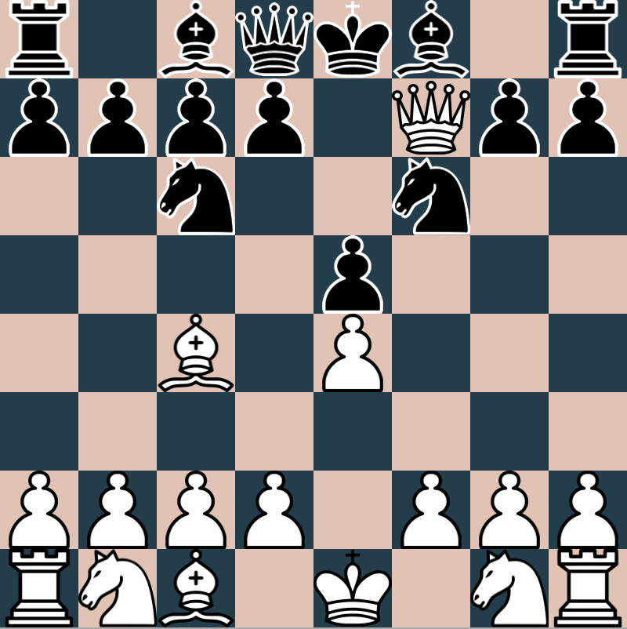

Citing Sources
If you need to cite any sources that helped with the completion of your assignment, do so in a clearly visible comment in Chess.hs. In particular, use these instructions if you need to acknowledge the use of generative AI.

Communicating
Do not post your code publicly, even for Task 0, on Ed Discussions or via any other means.
Once again, and we cannot stress this enough: do not post your code publicly . If you need help with your code, post it privately to the instructors.
When brainstorming with your friends, do not view each others’ code for anything other than Task 0. There might be pressure from your friends, but this is for both your and their benefit.
Sharing concepts and sketches is perfectly fine, but sharing should stop before you risk handing in suspiciously similar solutions.
Course staff will not look at assignment code unless it is posted privately in Ed Discussions, or shared in a drop-in consultation.
Course staff will typically give assignment assistance by asking questions, directing you to relevant exercises from the labs, or definitions and examples from the lectures. They will not give direct instructions on how to edit your Task 1, 2 or 3 code, but they will give you more generous help for questions related to Task 0.

Submission Checklist
- You have fully read and understand the entire assignment specification.
- You have fully cited any and all work (including generative AI) that you have used in a clearly visible comment in Chess.hs
- Your program compiles and runs. The only files in the scaffold that are allowed to be changed are Chess.hs and Examples.hs. If any other files are changed, auto-testing may fail.
- Your program runs in the Ed Lessons environment - if the program does not work in Ed Lessons, it might fail tests used by the instructors.

